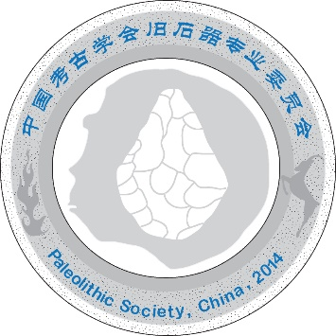

First Circular
The Tenth Meeting of the Asian Paleolithic Association (APA), China

Dear Sir/Madam,
On behalf of Organizing Committee you are kindly invited to participate in the Tenth Meeting of the Asian Paleolithic Association (APA), which will be held at Zhengzhou City, Henan Province, central China from August 22 to August 28, 2020. Organized by Paleolithic Society of China on behalf of the Presidium of the Asian Paleolithic Association (APA), the conference will provide an opportunity to share new Paleolithic archaeological discoveries and research achievements throughout Asia, promote the communication and cooperation of Paleolithic Archaeology in Asia. While details will be announced in due course, please feel free to share information in this announcement with other colleagues.
We kindly ask you to propose the titles of presentations until February 1, 2020, using the form below:

FIRST CIRCULAR REPLY FORM
The 10th APA Conference, 2020, Zhengzhou, China
Please return the form by February 1, 2020, to lifeng@ivpp.ac.cn or wangshejiang@ivpp.ac.cn
Family Name:
Given Name:
Country:
Gender:
Affiliation:
Email:
Accompanying person(s):
If you are accompanied, please provide his/her/their name(s).
Participation
( ) I will participate in the conference but cannot give an oral presentation.
( ) I will participate in the conference and give a poster presentation.
( ) I plan to give an oral presentation with the following title.
Title:
Post-conference excursion
( ) I will not join the excursion.
( ) I will join the excursion.

We look forward to receiving your replies and to seeing you in China in 2020!

Sincerely,

Honorary Presidents of the Asian Paleolithic Association

Prof., Xing Gao

President of the Asian Paleolithic Association
Prof., Youping Wang

Secretariat

Prof., Shejiang Wang
Dr. Feng Li
Dr. Fuyou Chen
Dr. Fei Peng

Preliminary Conference Schedule：

August 22 (Saturday)
Arrival Zhengzhou & Registration

August 23 (Sunday)
Conference Sessions

August 24 (Monday)
Conference Sessions

August 25 (Tuesday)
Conference Sessions
August 26 (Wednesday)
Post-Conference Excursion (Visit Paleolithic sites and museums near Zhengzhou)

August 27 (Thursday )
Post-Conference Excursion(Visit Paleolithic sites and museums near Zhengzhou)

August 28 (Friday)
Departure

Registration Fee：
The registration fee for the participant is about USD $ 300 per person （include meals and excursion）, which will NOT include accommodations for the conference period.

